This is a sophisticated, "hybrid" career path. You are essentially building a DevOps Engineer who can also handle Enterprise IT (Microsoft) and AI Operations (MLOps).
Because this exact combination doesn't exist in one single course, I have engineered a Modular Coursera Curriculum for you. This list is organized by "competency blocks" to take you from Beginner to Advanced efficiently.

Phase 1: The Core Engine (DevOps & CI/CD)
Goal: Master the tools to build, test, and deploy software automatically.
1. Primary Certification: IBM DevOps and Software Engineering Professional Certificate
- Why: It is the most complete "zero-to-hero" path on Coursera. It hits 60% of your list in one go.
- Key Topics Covered:
  - CI/CD: Jenkins, GitHub Actions, and Pipelines.
  - Containers: Docker & Kubernetes (OpenShift).
  - Automation: Python and Shell Scripting (Bash).
  - Methodology: Agile, Scrum, and DevOps culture.
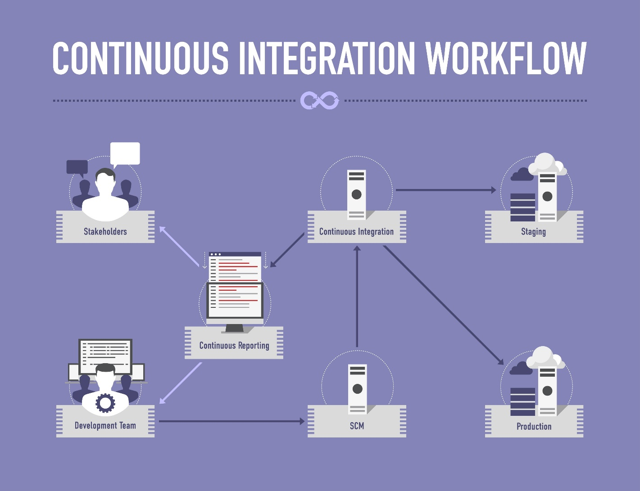
Shutterstock
2. The Kubernetes Upgrade: ArgoCD Essentials: Automating Kubernetes Deployments
- Why: The IBM course teaches you K8s basics. This short course teaches you GitOps (deploying via Git), Helm, and ArgoCD, which are non-negotiable for modern senior roles.

Phase 2: Infrastructure & Cloud (IaC & Networking)
Goal: Automate the servers and networks where your code lives.
3. Infrastructure as Code: Terraform in AWS from Basics to Guru
- Why: You need to manage infrastructure using code, not by clicking buttons. This course focuses specifically on Terraform within an AWS context, covering VPCs and networking.
  - Alternative if you prefer multi-cloud: Terraform Masterclass (Packt).
4. Cloud Cost & Management: Fundamentals of Cloud FinOps
- Why: Your requirement to "manage billing and optimize costs" is a specific discipline called FinOps. This course teaches you how to read a cloud bill and cut costs.

Phase 3: The AI & Data Layer (MLOps)
Goal: Learn to deploy AI models, not just web apps.
5. The Gold Standard: Machine Learning Engineering for Production (MLOps) Specialization
- Why: Created by Andrew Ng’s DeepLearning.AI. It bridges the gap between a "Data Scientist" (who builds models) and a "DevOps Engineer" (who runs them).
- Key Topics Covered:
  - Model Serving: Serving models via API (fast).
  - Data Pipelines: Handling data drift and retraining.
  - Deployment: Deploying ML models to devices and cloud.

Phase 4: The Enterprise IT Layer (Microsoft & Security)
Goal: Manage the humans, devices, and compliance laws.
6. Device Management: Managing Security & Enrollment with Intune
- Why: This is the specific "IT Admin" skill in your list. It covers managing Windows/Android devices, policies, and updates via Microsoft Intune.
7. Compliance & Security: Mastering ISO 27001 Controls: Implementation and Auditing
- Why: To meet your HIPAA/GDPR/ISO requirement. This teaches you how to implement the actual security controls required by international standards.

Summary Checklist
Phase | Skill Set | Recommended Course (Coursera)
1 | DevOps Core (Python, Docker, CI/CD) | IBM DevOps & Software Engineering Pro Cert
1 | GitOps (ArgoCD, Helm) | ArgoCD Essentials
2 | IaC (Terraform, AWS) | Terraform in AWS from Basics to Guru
2 | FinOps (Billing, Cost) | Fundamentals of Cloud FinOps
3 | MLOps (AI Deployment) | MLOps Specialization (DeepLearning.AI)
4 | IT Admin (Intune, AD) | Managing Security & Enrollment with Intune
4 | Compliance (ISO, HIPAA) | Mastering ISO 27001 Controls

Highest Brain Guideline: How to execute this?
Do not try to do these all at once.
- Start with Phase 1 (IBM Cert). It is the longest and most foundational.
- Do Phase 4 (Intune) in parallel if you are currently working in an IT support role; otherwise, save it for last.
- Phase 3 (MLOps) is the hardest. Only start this once you are comfortable with Docker and Python from Phase 1.
Would you like me to create a "Capstone Project" idea that combines all these skills (e.g., "Deploying a Secure AI Model to a Fleet of Intune-Managed Devices") to help you build your portfolio?

